SQL Interview Questions

- A database language used for defining the whole database structure and schema is called

  - DCL
  - DML
  - DDL
  - All Of Above

- How can the user change a value in the column named “Database” from “Oracle” to “Sql” in a table named Users?

a. UPDATE Users SET Database = Oracle INTO Database = Sql
b. UPDATE Users SET Database = ‘Sql’ where Database = ‘Oracle’
c. UPDATE Users SET Database = ‘ Sql ’ where Database like ‘ Oracle ’
d. UPDATE Users SET Database = ‘Oracle’ where Database like ‘Sql ’

- What is the name of the query that is placed within a WHERE or HAVING clause of another query?

  - Multi query
  - Sub query
  - Super query
  - Master query

- Which statement in SQL allows us to change the definition of a table?

  - ALTER
  - UPDATE
  - CREATE
  - SELECT

- Which of the following is not a valid SQL data type?

  - NUMERIC
  - DECIMAL
  - CHARACTER
  - None of the above

- Which function is used to divide one numeric expression by another and get the remainder?

  - POWER
  - MOD
  - ROUND
  - REMAINDER

- Which SQL function is used to count the number of rows in a SQL query?

  - COUNT()
  - NUMBER()
  - SUM()
  - COUNT(*)

- ___________removes all rows from a table without logging the individual row deletions.

  - DELETE
  - REMOVE
  - DROP
  - TRUNCATE

- Which of the following statement is true?

  - DELETE does not free the space containing the table and TRUNCATE free the space containing the table
  - Both DELETE and TRUNCATE free the space containing the table
  - Both DELETE and TRUNCATE does not free the space containing the table
  - DELETE free the space containing the table and TRUNCATE does not free the space containing the table

- Which of the following is Policy based Management related to administration?

  - Identify the SQL Server Databases not in Full recovery Model
  - SQL Server Policy based management has clustered Index Condition
  - Evaluate and Implement Policies in Multiple SQL Server Instances
  - All of the above

- Which of the following is used to validate the database objects?

  - DBCC SHOWCONFIG
  - DBCC CHECKDB
  - DBCC CATALOG
  - None of the above

- Pick out the correct Statement

  - Rollback Transaction with a Savepoint_name or Transaction_name rolls back to the beginning of the transaction
  - Issuing a COMMIT Transaction when @@TRANCOUNT is 0 results in an error
  - A ROLLBACK Transaction does not produce any messages to the user
  - All of the above

- Pick out the wrong statement

  - SQL Server supports only clustered and non-clustered index types
  - Appropriate indexes can make world of difference in performance
  - SET Option requires ALTER Permission on the table or View
  - None of the above

- Pick out the wrong statement

  - Prior to SQL Server 2008, if a deadlock occurred in SQL Server, Trace flag needs to be enabled.
  - SQL Server Lock Monitor has a deadlock detector that periodically checks the locks
  - A Dead Lock graph shows the sessions and resources that were involved in a deadlock
  - None of the above

- ___________ Permissions default to any valid user

  - ROLLBACK WORK
  - COMMIT
  - ROLLBACK
  - None of the above

- Which of the following is not a Foreign Key Constraint?

  - NO ACTION
  - SET NULL
  - CASCADE
  - All of the above

- Which of the following code deletes node A using hierarchical data type?

  - DELETE A where Name=’Steve’
  - DROP from A where Name=’Steve’
  - DELETE from A where Name=’Steve’
  - None of the above

- The UNION SQL Clause can be used with which of the following?

  - DELETE and UPDATE Clauses
  - UPDATE Clause Only
  - SELECT Clause Only
  - All of the above

- Insert into Employee_________(1001, ‘ABC’ , ‘SQL’)
In the above query which of the following keyword to be used?

  - Field
  - Values
  - Table
  - Relation

- Which of the minimal permission that a user must have to drop the database?

  - VIEW
  - READ
  - CONTROL
  - WRITE

Answer Key
1. C
2. B
3. B
4. A
5. C
6. B
7. D
8. D
9. A
10. C
11. B
12. B
13. A
14. D
15. A
16. C
17. C
18. C
19. B
20. C

99 ChatGPT tabs → 9 SQL patterns.
No more guessing.
1) See the problem.
2) Know the pattern.
3) Write the query.
Here are the 9 patterns that solve 90% of SQL problems 👇
📊 Data split across columns?
→ UNION ALL
🔄 Compare within same table?
→ SELF JOIN
⏳ Track changes over time?
→ LAG/LEAD
📍 First/last occurrence?
→ MIN/MAX + GROUP BY
⚡ Complex multi-step transformation?
→ CTE LAYERING
🏆 Top N per group?
→ WINDOW FUNCTIONS (RANK)
📈 Running totals or averages?
→ RUNNING AGGREGATES
↔️ Rows need to become columns?
→ PIVOT LOGIC (CASE + SUM)
🎯 Multiple counts, different conditions?
→ CONDITIONAL AGGREGATION
The moment this clicked for me -
I stopped asking "what's the syntax?"
I started asking "which pattern is this?"
That one shift made me 10x faster. 🚀
---
♻️ Repost it to help your network learn SQL the EASY way!
🔔 FOLLOW + Hit the bell here, ( Anandnarayanan S ) for daily SQL shortcuts that actually stick.
Activate to view larger image,
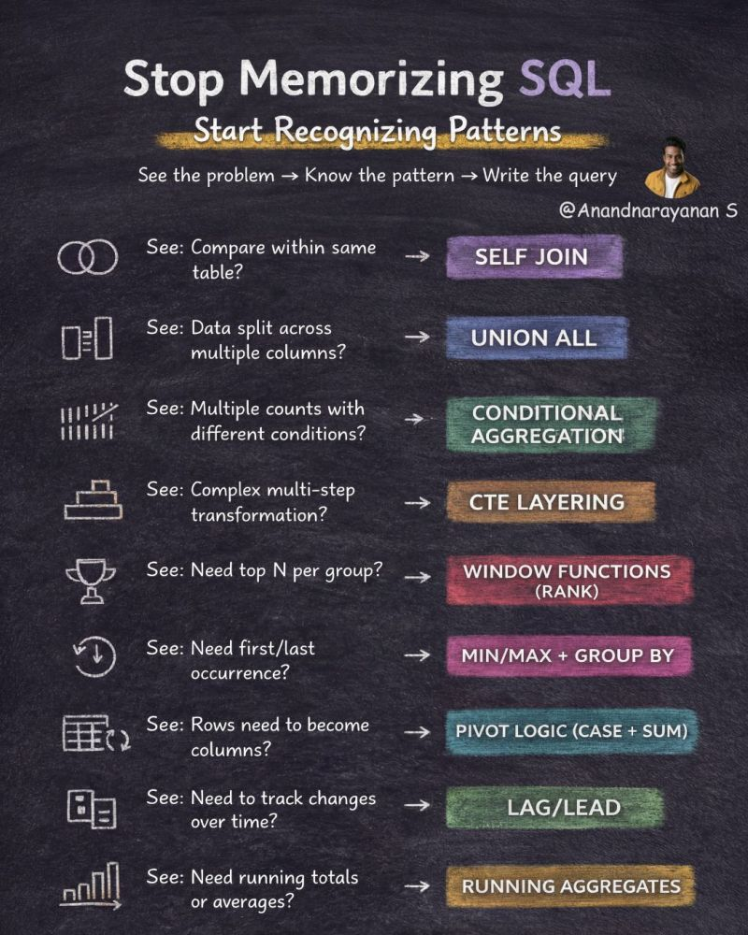

Xylem — Senior Data Analyst
Technical Round (13 LPA)
Panel: 3 Interviewer
Duration: 52 Minutes
Q1. How do you approach optimizing a slow-running stored procedure step by step?
Q2. What is the difference between correlated and non-correlated subqueries — and the performance impact?
Q3. What are window functions, and what does the PARTITION BY clause change?
Q4. Explain KEEPFILTERS and when you'd add it inside CALCULATE.
Q5. Difference between a star schema measure written with RELATED vs one relying on the relationship directly.
Q6. Scenario: Report needs near-real-time data but also 3 years of history. Import is too slow, DirectQuery is too heavy. What's your design?
Q7. What is incremental refresh, and what are the real-world issues you've hit with it?
Q8. How do you handle NULLs in joins so you don't silently lose rows?
Q9. What is the difference between a Gateway (personal vs standard) and when do you need one?
Q10. Scenario: Same measure gives different results in a matrix vs a card visual. Why?
Q11. How do you optimize a model where one dimension has 5 million+ unique values?
Q12. Difference between PIVOT and UNPIVOT — and when you'd unpivot in Power Query.
Q13. What is a surrogate key and why not just use the source system's natural key?
Q14. How do you debug a DAX measure using variables and step-by-step evaluation?
Q15. What are the main causes of a bloated PBIX file, and how do you shrink it?
Hope this helps anyone preparing for Power BI, SQL, and Data Engineering interviews!

𝗠𝗮𝘀𝘁𝗲𝗿 𝟭𝟬𝟬+ 𝗦𝗤𝗟 𝗙𝘂𝗻𝗰𝘁𝗶𝗼𝗻𝘀 𝗙𝗼𝗿 𝗗𝗮𝘁𝗮 𝗘𝗻𝗴𝗶𝗻𝗲𝗲𝗿 𝗜𝗻𝘁𝗲𝗿𝘃𝗶𝗲𝘄𝘀
If you're preparing for Data Engineer, Data Analyst, SQL Developer, or BI interviews, these SQL functions are a must-know.
This cheat sheet covers almost every category asked in real interviews.
𝗜𝗻𝗰𝗹𝘂𝗱𝗲𝘀:
✅ String Functions
✅ Numeric Functions
✅ Aggregate Functions
✅ Window / Analytic Functions
✅ Date & Time Functions
✅ NULL Functions
✅ Conversion Functions
𝗠𝗼𝘀𝘁 𝗮𝘀𝗸𝗲𝗱 𝗳𝘂𝗻𝗰𝘁𝗶𝗼𝗻𝘀:
• ROW_NUMBER()
• RANK() & DENSE_RANK()
• LAG() & LEAD()
• NTILE()
• FIRST_VALUE() & LAST_VALUE()
• CUME_DIST() & PERCENT_RANK()
• COUNT(), SUM(), AVG(), MIN(), MAX()
• COALESCE(), IFNULL(), NVL(), NULLIF()
• CAST(), TO_DATE(), TO_TIMESTAMP()
• CURRENT_DATE(), DATE_ADD(), DATEDIFF()
• ABS(), ROUND(), FLOOR(), CEIL(), POWER()
• UPPER(), LOWER(), SUBSTRING(), CONCAT(), REPLACE()
…and many more.
Mastering these functions will help you solve:
SQL coding rounds
Scenario-based interview questions
Real production data transformations
Query optimization problems
💙 Like 👍 & Save 🔖 for later.
🔄 Share this post if it adds value to your interview prep.
Comment below 👇 Which SQL function do you use the most in your daily work?
𝗙𝗼𝗿 𝟭:𝟭 𝗴𝘂𝗶𝗱𝗮𝗻𝗰𝗲
https://lnkd.in/gxjZT5P3
🚀 𝗟𝗲𝘃𝗲𝗹 𝘂𝗽 𝘆𝗼𝘂𝗿 𝗗𝗮𝘁𝗮 𝗘𝗻𝗴𝗶𝗻𝗲𝗲𝗿𝗶𝗻𝗴 𝗽𝗿𝗲𝗽:
🔹 𝗦𝗤𝗟 𝗜𝗻𝘁𝗲𝗿𝘃𝗶𝗲𝘄 𝗠𝗮𝘀𝘁𝗲𝗿𝘆 – 𝟮𝟬𝟬+ 𝗤𝘂𝗲𝘀𝘁𝗶𝗼𝗻𝘀
https://lnkd.in/dYJb42RH
🔹 𝗣𝘆𝗦𝗽𝗮𝗿𝗸 𝗜𝗻𝘁𝗲𝗿𝘃𝗶𝗲𝘄 𝗣𝗿𝗮𝗰𝘁𝗶𝗰𝗲 – 𝟵𝟲 𝗤𝘂𝗲𝘀𝘁𝗶𝗼𝗻𝘀
https://lnkd.in/dwCEinvH
🔹 𝗗𝗮𝘁𝗮 𝗘𝗻𝗴𝗶𝗻𝗲𝗲𝗿 𝗣𝘆𝘁𝗵𝗼𝗻 𝗜𝗻𝘁𝗲𝗿𝘃𝗶𝗲𝘄 – 𝟭𝟬𝟬 𝗤𝘂𝗲𝘀𝘁𝗶𝗼𝗻𝘀
https://lnkd.in/dwKVeFf7
👉 Follow Anuj Shrivastav for more Data Engineering interview content.
hashtag#SQL hashtag#DataEngineering hashtag#SQLInterview hashtag#DataEngineer hashtag#PySpark hashtag#Databricks hashtag#Azure hashtag#Analytics hashtag#Database hashtag#InterviewPreparation

